D C CIRCUITS

Learning Objectives

At the end of the lesson, you should be able to:

- Calculate the combined resistance of two or more resistors in series.

- Calculate the combined resistance of two or three resistors in parallel.

Electric Circuits

Electric circuits can be classified into two categories:

- Series Circuits
- Parallel Circuits

Electric Circuit

Resistors Arrangement

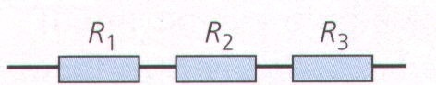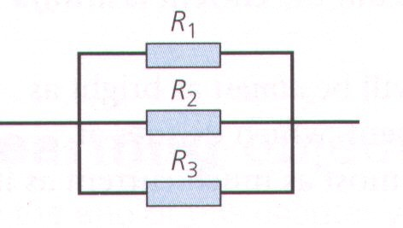

Resistors and Resistance
- Resistors can be connected either in:

- Series  Parallel

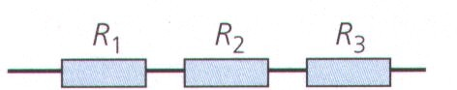

Resistors in Series

- The total resistance (effective resistance or resultant resistance) is equal to the sum of the individual resistance.

Rtotal = R1 + R2 + R3

Resistors in Parallel

  - The reciprocal of the total resistance (effective resistance or resultant resistance) is equal to the sum of the reciprocal of individual resistance.

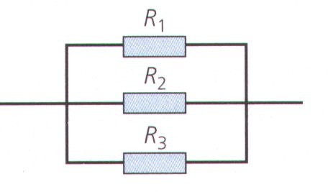1
Rtotal
= 1 + 1 + 1
R1 R2 R3

Resistors in Parallel
  - If two resistors of resistance R1 and R2 are connected in parallel, the total/effective resistance is smaller than the R1 & R2.

I1
R1

I2
R2

Then
1 = 1 + 1 ,

Hence R
= R1R 2

R total
R1 R 2
total
R1 +R 2

Summary (Resistance)
Resistors in series Resistors in parallel

  - The combined resistance, R, of resistors in series is found by adding up all the individual resistance
  - The combined resistance, R, of resistors connected in parallel is less than that of any one of the resistors

R = R1
+ R2
+ R3

+…..
1 = 1 + 1 + 1
R R1 R 2 R 3
+ ....

D.C Circuit

Part 2 : Current in Series & Parallel Circuits

Learning Objectives
At the end of the lesson, you should be able to:

  - Show understanding that current at every point in the series circuit is the same.

  - use the fact that the current from the source is the sum of the currents in the separate branches of a parallel circuit.

Current in Series Circuits
  - A series circuit has only one path in which charge can flow.

Battery

Switch

I
I1 I2 I3 R
R
R

The current is same everywhere. ( I = I1 = I2 = I3 )

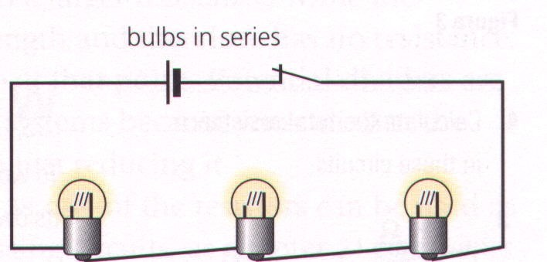

Current in Series Circuits
What will happen if one of the lamp is being removed?

Answer: The rest of the lamps will not light up.

Pause and Think …

What about the lighting circuits in your house, do you think they are connected in series?

What will happen if they are connected in series?

How then do you think the lights should be connected?
WHY?

Current in Parallel Circuit
  - A parallel circuit has more than one path for the current to flow.

I1
I
R1
I2
R2
I3
R3
Switch

I

The main current is equal to the sum of the sub-currents. ( I = I1+I2+I3 )

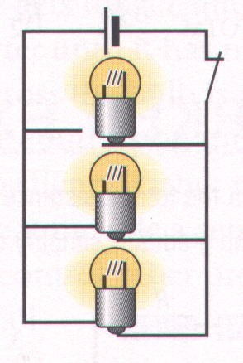

Current in Parallel Circuit

What will happen if one of the lamp is being removed?

Answer:
Apart from the lamp that was being removed, the rest of the lamp will continue to light up.

A B
t

Short Circui

  - In the fig. shown, AB is a copper wire which connects two point A and B in the circuit.

  - Since the copper wire has very little resistance, therefore a large amount of current will flow through it.

  - The lamp then go off. (Why?)

  - Therefore we say this circuit is now a short circuit.

Summary

  - A series circuit has only one path for the current to flow.
  - The current is the same throughout the circuit in a series circuit.

  - A parallel circuit has more than one path for the current to flow.
  - The current, in general is different at different points for a parallel circuit.

D.C Circuit

Part 3 :
P.D/Voltage in Series & Parallel Circuits

Learning Objectives
At the end of the lesson, you should be able to:

  - Use the fact that the sum of the p.d.’s in a series circuit is equal to the p.d. across the whole circuit.

  - use the fact that the p.d. across all the components in a parallel circuit is the same.

P.D. in Series Circuits
V1
Switch

I V2 V3 V4

L1 L2 L3
V1= V2 + V3 + V4

P.D. in Series Circuits

  - The sum of the p.d across individual components in a series circuit, is equal to the p.d across the whole circuit.

  - The component with the largest resistance has the highest potential difference across it (i.e. V = I x R)

in Parallel Circuit
V1

V1 = V2 = V3 I I I2
1
Switch

V2

V3

Summary

The p.d. across all the components in a parallel circuit is the same.

  - The sum of the p.d. across individual components in a series circuit, is equal to the p.d. across the whole circuit.

Series & Parallel Circuits

Series Circuit
  - A series circuit has only one path for the current to flow.
  - I = I1 = I2 = I3
  - The sum of the p.d. across individual components in a series circuit, is equal to the p.d. across the whole circuit.
Parallel Circuit
  - A parallel circuit has more than one path for the current to flow.
  - I = I1+ I2 + I3
  - The p.d. across all the components in a parallel circuit is the same.

Worked Example
  - A voltage of 4V is supplied to two resistors of (6 Ω and 2 Ω ) connected in series. Calculate
    - the combined resistance,

    - the current flowing,
    - the p.d. across the 6 Ω resistor.
Solution
      - combined resistor = 6 + 2 = 8 Ω
      - since V= RI,
4 = 8 x I, I = 0.5 A (c) V6Ω = 6 x 0.5 = 3 V

I

6Ω 2Ω
4V

Worked Example
- A voltage of 12 V is supplied to two resistors of (3 Ω and 6 Ω )

connected in parallel. Calculate
- the combined resistance,
- the current flowing in the main circuit,
- the current in the 3 Ω resistor.
Solution
- combined resistor = (R1R2) / (R1+R2)
= (3 x 6) / (3+6)
= 2 Ω
3 Ω

6 Ω

12 V

- since V= RI,
12 = 2 x I, I = 6 A
- current through 3 Ω = 12 / 3 = 4 A

Worked Example
- The battery in the circuit illustrated has an e.m.f. of 16 V and negligible internal resistance. Calculate

- the combined resistance,
- the current flowing through the 8 Ω resistor.

Solution
16V

36Ω
8Ω
R1

R3

- combined resistor = [(R
R2
1R2)
/ (R
1+R
2)] + R3
18Ω

= [(36x18) / (36+18)] + 8 = 20 Ω
- since V= RI,
16 = 20 x I, I = 0.8 A
hence, current through 8 Ω resistor is 0.8 A

